Tyler Thompson

1/16/23

tjt5498@psu.edu

**Lab 3**

**Objective**

Have the robot perform a circle as best as it can and replicate the results to show that the program is successful.

**Results**

The tests were almost all exactly the same. The final landing spot had been slightly different for each result but overall, each test indicated a successful run.

Video Link - <https://share.icloud.com/photos/02awPqRbv40A4hoYV3_1Lk7-A>

**Result 1**

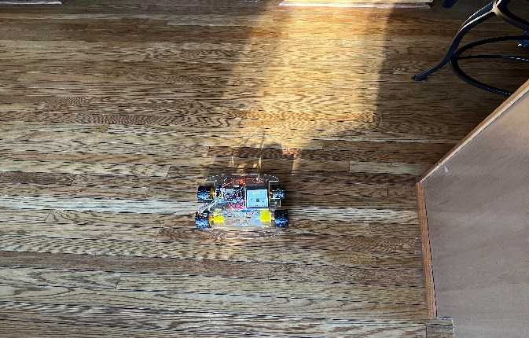

The result for this test was great and the robot was just a bit off as I wanted it to face all the way back in the starting position. After measuring it was concluded to be around 3 to 4 inch away from the original spot.

**Result 2**

This was the best test overall and I was really happy with it and knew at this point the program was a success and I could definitely stick with it. The tape was almost exactly in the center which is where it started. After I measured it was only 1 inch of the original spot.

**Result 3**

This was another great test and although not as good as the last, it confirmed that the results could easily be replicated with the code.

|  |  |
| --- | --- |
| Trail Number | Distance From Tape (Max / Min) |
| Trail 1 | 3 to 4 in |
| Trail 2 | 1 in |

**Conclusion**

This program had some difficulty that came with it. It took quite a while to not only sync the robot to make it land at the spot but also to make the circle almost perfect. The biggest issue was when the robot had started up, one wheel was spinning before the other wheel which made it spin a lot faster which eventually just threw the entire arc off. To deal with this I came up with a solution that first had the robot move forward by a very small amount. This amount was so small it was not even noticeable. This then allowed the motors to be in sync and start completing the arc at the same time. From there the final solution had been obtained and the results could be replicated without any problem indicating that it had been a success.